**Results of Circuit s27**

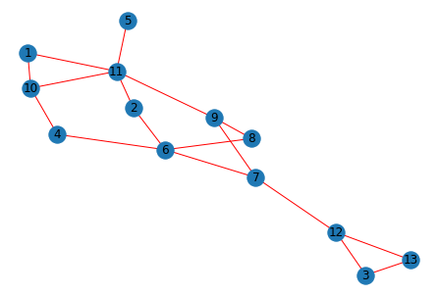

Fig 1: Initial Graph of s27

No. of vertex:13

No. of Edges: 17

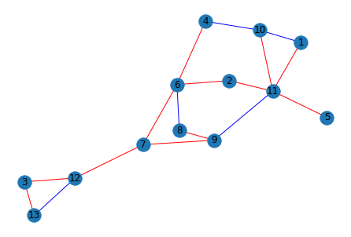

Fig 2: Graph after partitioned

Edgelist in betree index: 0

Edge : (1, 11)

Edge : (11, 2)

Edge : (2, 6)

Edge : (6, 4)

Edge : (6, 7)

Edge : (7, 9)

Edge : (9, 8)

Edge : (7, 12)

Edge : (12, 3)

Edge : (3, 13)

Edge : (11, 5)

Edge : (10, 11)

Edgelist in betree index: 1

Edge : (1, 10)

Edge : (6, 8)

Edge : (9, 11)

Edge : (12, 13)

Edge : (4, 10)

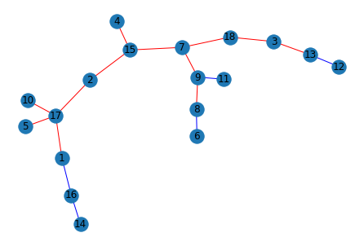

Fig 3: Final Graph after vertex_split

Total number of vertex finally after all partition : 18

Edges in Be Tree: 0

(1, 2)

(2, 3)

(3, 4)

(4, 5)

(5, 6)

(6, 10)

(10, 16)

(16, 8)

(8, 9)

(10, 18)

(18, 11)

(4, 13)

Edges in Be Tree: 1

(1, 15)

(2, 14)

(14, 12)

(15, 17)

(7, 9)

No of betree: 1

No of vertex split: 5

No of label swap: 2

no.of edge-swap: 0

no of extra_labels: 1

The nodes which should be stored for extra labels: [17]

To convert into prufer sequence we take node with id 1 as root node

Prufer Sequence:

[9, 8, 16, 18, 14, 4, 2, 10, 15, 1, 10, 6, 5, 4, 3, 2]